Come for dinner (provided).

Stay for Multi-Generational Vacation Bible School

HOLY CROSS LUTHERAN CHURCH

Evenings - August 12-16 – 6 to 8pm

REGISTER: after services in the Narthex or online: vbsmate.com/HCLCVBS

KIDS discover God’s Promise on life’s Wild Ride.
MUSIC † CRAFTS † GAMES † STORYTELLING † BIBLE CHALLENGE

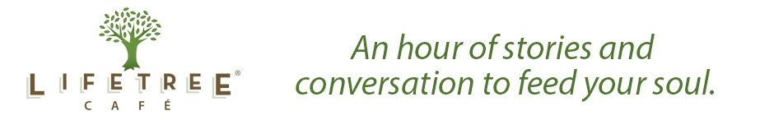

Sunday-Tuesday, Thursday

ADULTS participate in Lifetree Café

SUNDAY-TUESDAY, THURSDAY
- What’s God Up To? – Unwelcome (surprising) answers to prayer
- Simplify Your Life – How a Hollywood millionaire walked away from it all
- Family Secrets – What mama never told us
- 10 Minutes to Live – Now What?

WEDNESDAY: Pastor Leila Ortiz speaks to us about Puerto Rico NOW –HOW CAN WE HELP?

